**BANK LOAN REPORT QUERY DOCUMENT**

1. **BANK LOAN REPORT | SUMMARY**

**KPI’s:**



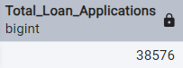

(MTD)MONTH TO DATE

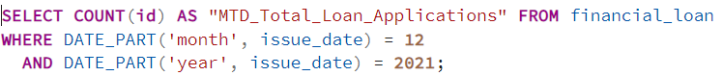

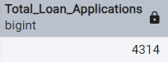

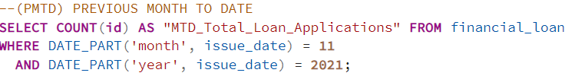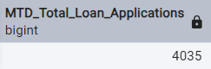

Total Funded Amount :-



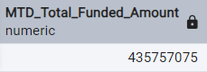

**MTD Total Funded Amount**



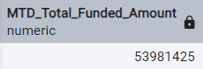

**PMTD Total Funded Amount**



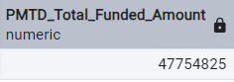

**Total Amount Received**



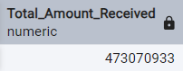

**MTD Total Amount Received**



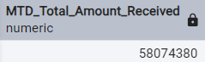

**PMTD Total Amount Received**



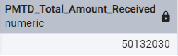

**Average Interest Rate** :-



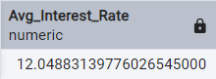

**MTD Average Interest**



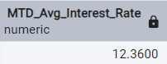

**PMTD Average Interest**



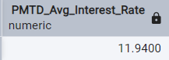

**Avg DTI**



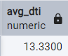

**MTD Avg DTI**

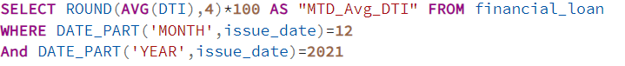

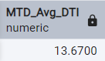

**PMTD Avg DTI**

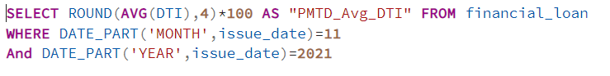

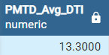

**GOOD LOAN ISSUED**

